

**Thursday 13th July 2023**

**8.30am-2.00pm**

 

***Event Rules***

**All competitors must wear appropriate sports kit.**

**All track events take priority over field events, athletes whose events clash should report to the field event then go straight to the track event.**

**Track and competition areas are out of bounds to spectators.**

**No students to leave the Stadium Complex until they are dismissed at 2.30pm.**

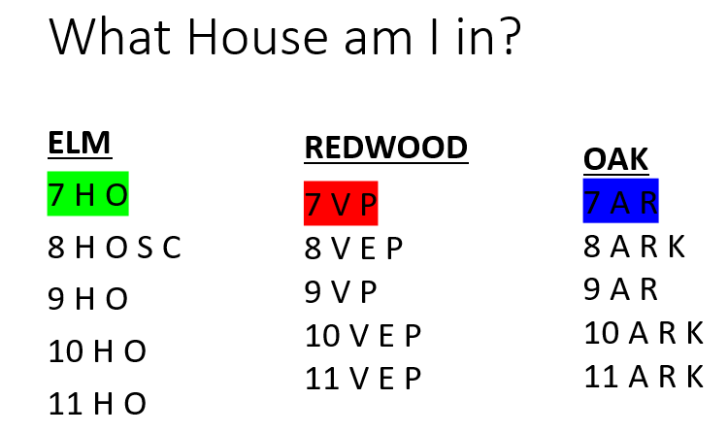

#### Youzafzai/ Phoenix Roddick Hawking Mandela Turing Competitors

**Cullum Redwood Elm Oak Parents/carers**

**+**

**Quiet area**

Race Starting Positions

#### ***Championship Officials***

|  |  |
| --- | --- |
| **Championships Co-ordinators** | PE Department |
| **Starter** | A. Mack |
|  |  |
| **Time Keepers**  **Track Judges/ Finish Line** | E Mulvenna, L Bear, R Benjamin, T Oliveira, S Secrett, L Pinney  E. Satterly, E. Vermeer, & S. Secrett |
| **Announcer** | A. Marshall |
| **Scorers & Results** | C. Waite, N. Skelton Day |
|  |  |
| **Long Jump**  **Triple Jump** | S Haque, J Blythe, S Bevan, D MacDonald  R Caudle, P Rafferty, D Martin |
|  |  |
| **High Jump** | J. Schofield, A. Alexander, J. Hammond , J. Hawkey |
| **Shot Put** | P Sumner, A Hunt, A Lyell, J Forder |
| **Javelin** | K. Gray, N. Wickens, S. Corrigal, V Tatton. |
| **Discus**  **Photographers** | M. Catling, T. Hunting, G Ball, G Sproat  E. Cave, K. Salter |
|  |  |

**Transport** P. Jones, S. Corcoran &

A. Adelaide

**First Aid** S. Speed, A. Sherwood, C Haynes, N Ahmed

**Refreshments** R.Scott, S Hutchings, J Williams, S Holt

PROGRAMME OF TRACK EVENTS

No. Time Event Final

1. 9.00 150m Girls Yr. 7 Time trials 150m Boys Yr. 7

2. 9.15 200m girls Yr 8 Time trials

200m Boys Yr.8

200m Girls Yr9

200m Boys Yr 9

200m Girls Yr10

200m Boys Yr 10

3. 9.45 600m Girls Yr.7 Time trials

600m Boys Yr 7

4. 10.00 800m Boys Yr 8 Time trials

800m Girls Yr 9 800m Boys Yr.9 800m Girls Yr 10

800m Boys Yr.10

5. 10.30 75m Girls Yr.7 Time trials

75m Boys Yr. 7

6. 11.05 100m Girls Yr 8 Time trials

100m Boys Yr 8

100m Girls Yr.9

100m Boys Yr 9

100m Girls Yr.10

100m Boys Yr 10

33. 12.00 Relay Girls Yr.7 Time trials

Relay Boys Y.7

35. 12.15 Relay Girls Yr.8 Time trials

Relay Boys Yr.8

37. 12.30 Relay Girls Yr.9 Time trials

Relay Boys Yr. 9

39. 12.45 Relay Girls Yr.10 Time trials

Relay Boys Yr. 10

PROGRAMME OF FIELD EVENTS

No Time Event

A 9.00 Long Jump Yr 7 Boys and Girls

B 9.00 Discus Yr 9 Boys and Girls

C 9.00 Javelin Yr 10 Boys and Girls

D 9.00 Shot Yr 8 Boys and Girls

E 9.00 High Jump Yr 7 Boys and Girls

F 10.00 High Jump Yr 8 Boys & Girls

G 10.15 Long Jump Yr 8 Boys and Girls

H 10.15 Discus Yr 10 Boys and Girls

I 10.15 Javelin Yr 7 Boys and Girls

J 10.15 Shot Yr 9 Boys and Girls

K 11.00 High Jump Yr 9 Boys and Girls

L 11.30 Long Jump Yr 9 Boys and Girls

M 11.30 Discus Yr 7 Boys and Girls

N 11.30 Javelin Yr 8 Boys & Girls

O 11.30 Shot Yr 10 Boys & Girls

P 12.30 Long Jump Yr 10 Boys & Girls

Q 12.00 High Jump Yr 10 Boys & Girls

R 12.30 Discus Yr 8 Boys & Girls

S 12.30 Javelin Yr 9 Boys & Girls

T 12.30 Shot Yr 7 Boys & Girls